Penetration testing final report

Vulnerability Report

Saturday, May 20, 2023

modifications history
Version | Date | Author | Description
1.0 | 05/20/2023 | Chawki Ben Salem | Initial Version (https://github.com/Chawki-BS/Web-Penetration-Testing-Results)

Table of Contents

1. General Information 4
1.1 Scope 4
1.2 Organisation 4
2. Executive Summary 5
3. Technical Details 6
3.1 title 6
4. Vulnerabilities summary 8

General Information

Scope
TEK-UP has mandated us to perform security tests on the following scope:
- http://testphp.vulnweb.com

Organisation
The testing activities were performed between 05/01/2023 and 05/20/2023.

Executive Summary

Vulnerabilities summary
Following vulnerabilities have been discovered:

Risk | ID | Vulnerability | Affected Scope
Critical | IDX-001 | Injection
Critical | IDX-004 | Cryptographic Failure
High | IDX-002 | Broken Access Control
Medium | VULN-003 | Security Misconfiguration

Technical Details

Injection
CVSS Severity | Critical |  | CVSSv3 Score |  | 9.8
CVSSv3 criterias | Attack Vector : | Network | Scope : | Unchanged
CVSSv3 criterias | Attack Complexity : | Low | Confidentiality : | High
CVSSv3 criterias | Required Privileges : | None | Integrity : | High
CVSSv3 criterias | User Interaction : | None | Availability : | High
Affected scope
Description | SQL Injection is a type of injection vulnerability where an attacker can execute arbitrary SQL statements by manipulating user input. This can lead to unauthorized access to sensitive data, modification of data, or even complete system compromise.
Observation | A successful SQL injection attack can allow an attacker to steal sensitive information, such as passwords, credit card numbers, or other personal or financial data. In some cases, an attacker can gain full access to the target system, allowing them to execute commands, modify or delete data, or even take over the entire system.
Test details
7- Data validation testing :
- Testing for Reflected Cross Site Scripting (CWE-79)
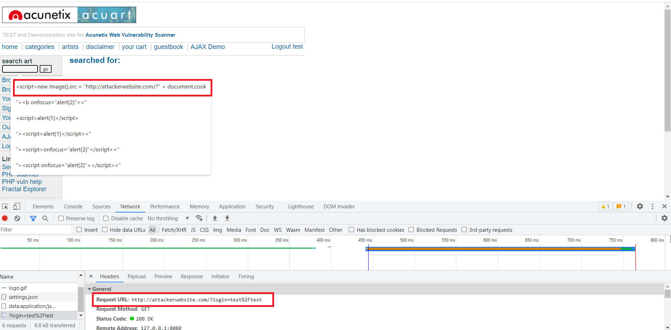
Image 1 – Reflected XSS.PNG
- Testing for Stored Cross Site Scripting (CWE-79)
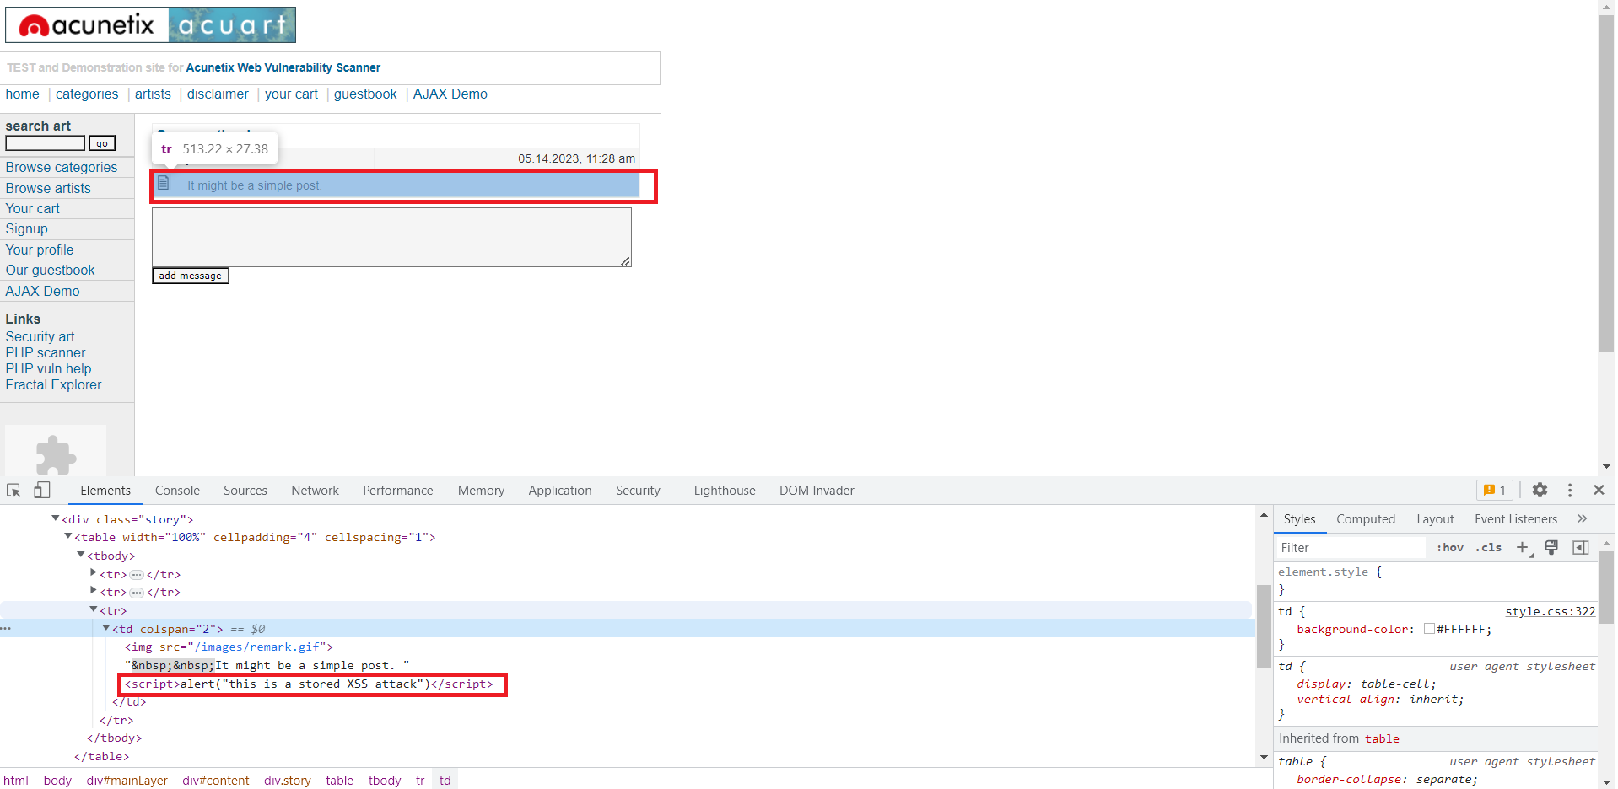
Image 1 – Stored XSS attack.png
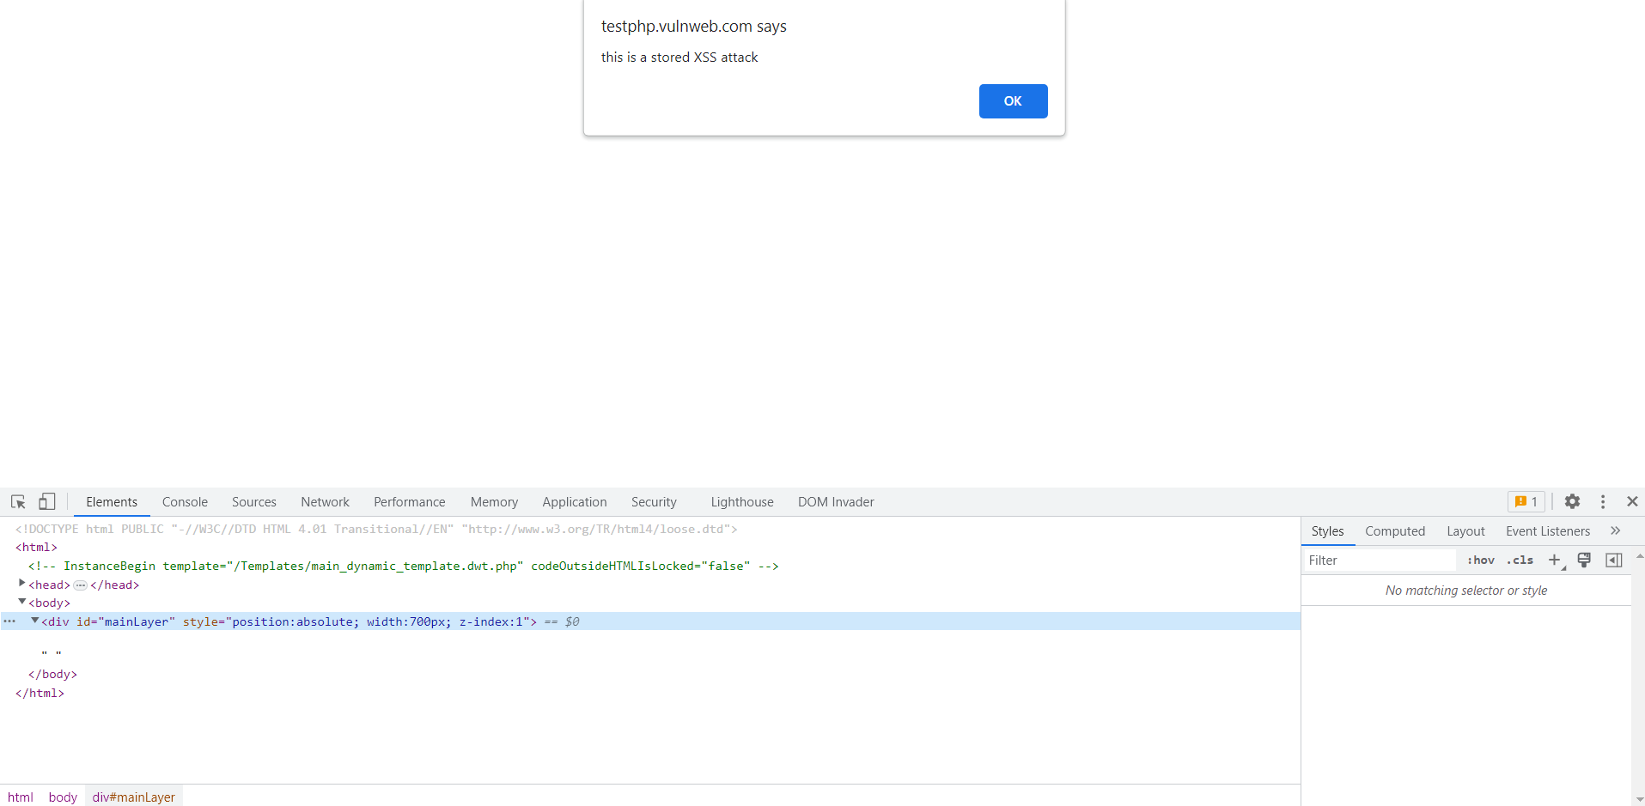
Image 1 – Stored XSS attack result.png
- Testing for SQL Injection (CWE-89)
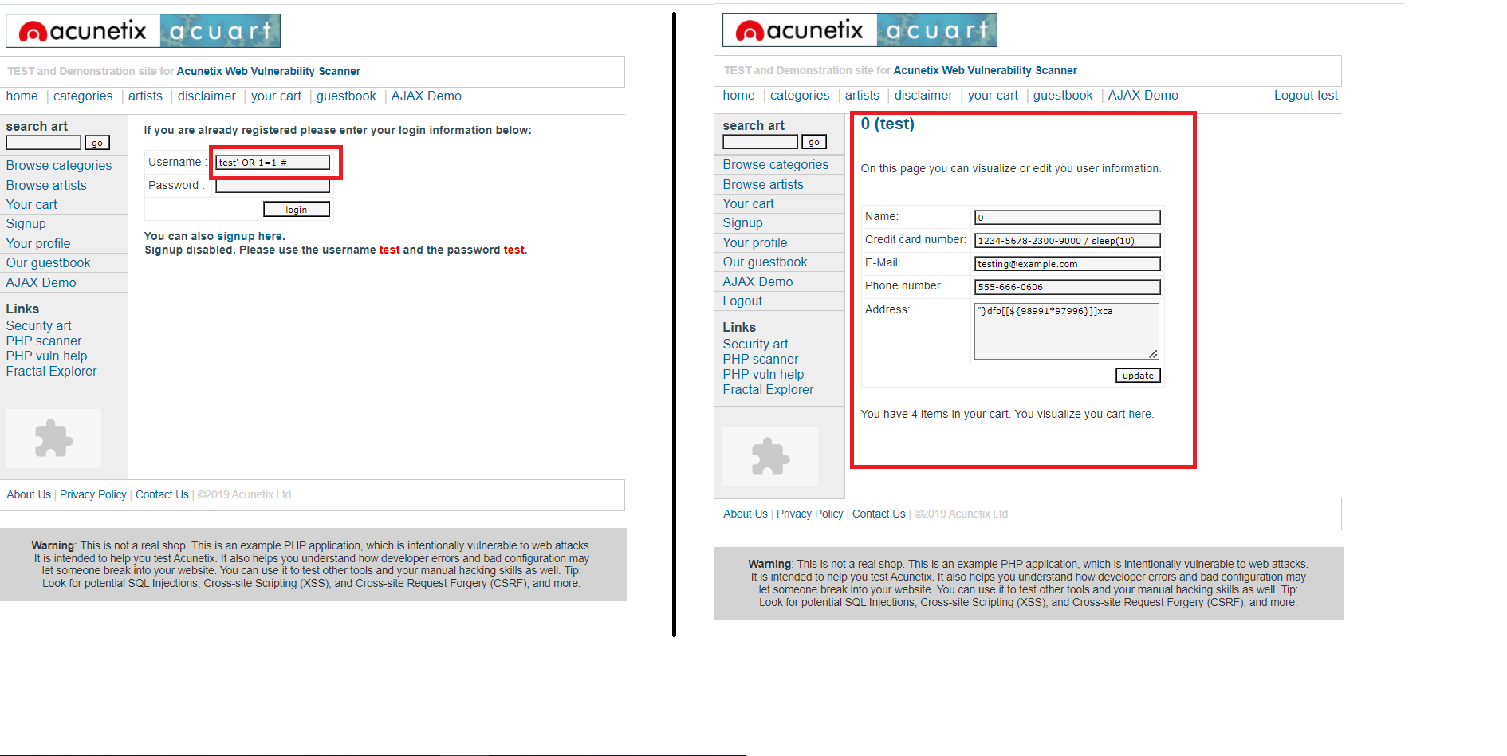
Image 1 – SQL injection.png
Remediation | The best way to prevent SQL injection attacks is to use parameterized queries, prepared statements, or stored procedures instead of directly concatenating user input into SQL statements. Additionally, input validation and sanitization should be performed on all user input to ensure that it only contains expected characters and values, and is free of any malicious code.
References | https://owasp.org/Top10/A03_2021-Injection/

Cryptographic Failure
CVSS Severity | Critical |  | CVSSv3 Score |  | 9.8
CVSSv3 criterias | Attack Vector : | Network | Scope : | Unchanged
CVSSv3 criterias | Attack Complexity : | Low | Confidentiality : | High
CVSSv3 criterias | Required Privileges : | None | Integrity : | High
CVSSv3 criterias | User Interaction : | None | Availability : | High
Affected scope
Description | The encryption of sensitive data is a common requirement in many applications. However, weak encryption algorithms or insufficient key sizes can result in the encrypted data being easily recoverable by an attacker. For example, using 128-bit AES keys or smaller, or using DES encryption, is no longer considered secure.
Observation | An attacker could potentially recover the sensitive data by using brute-force attacks or other cryptographic attacks against the weak encryption. In the case of insufficient key sizes, an attacker could also use precomputed tables or rainbow tables to crack the key. In addition, attacks on the cryptographic algorithms themselves may be possible, allowing an attacker to bypass the encryption entirely.
Test details
9- Cryptography:
Testing for Sensitive Information Sent via Unencrypted Channels (CWE311, CWE319, CWE 323)
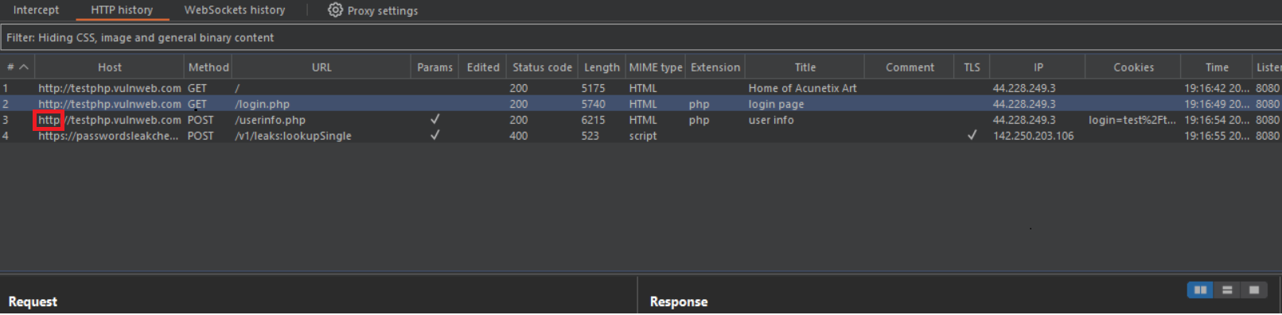
Image 1 – CWE311 CWE319.png
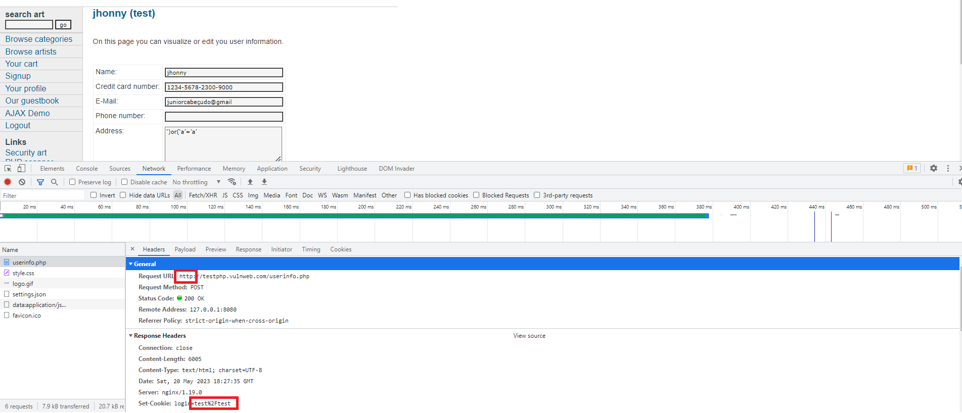
Image 1 – CWE 323.png
Remediation | Ensure that strong encryption algorithms with sufficiently long keys  are used to protect sensitive data. Refer to industry-standard  recommendations for key sizes and encryption algorithms, such as NIST  Special Publication 800-57 or similar. Consider using key derivation  functions (KDFs) to generate strong keys from weaker sources of entropy.  Implement proper key management practices to ensure that keys are  securely generated, stored, rotated, and destroyed when no longer  needed.
References | https://owasp.org/Top10/A02_2021-Cryptographic_Failures/

Broken Access Control
CVSS Severity | High |  | CVSSv3 Score |  | 7.3
CVSSv3 criterias | Attack Vector : | Network | Scope : | Unchanged
CVSSv3 criterias | Attack Complexity : | Low | Confidentiality : | Low
CVSSv3 criterias | Required Privileges : | None | Integrity : | Low
CVSSv3 criterias | User Interaction : | None | Availability : | Low
Affected scope
Description | Broken access control occurs when restrictions on what authenticated users are allowed to do are not properly enforced. Attackers can exploit these weaknesses to gain unauthorized access to resources or to perform actions that they should not be able to perform. The impact of this vulnerability can range from sensitive data leaks to full system compromise, depending on the specific scenario. This vulnerability is caused by improper access controls in the application, such as lack of authentication checks, missing authorization checks, or insufficient enforcement of least privilege.
Observation | An attacker can exploit this vulnerability to gain access to sensitive data, such as user accounts, personally identifiable information, or confidential business data. The attacker may also be able to execute unauthorized actions, such as modifying or deleting data or executing unauthorized commands. In some cases, this vulnerability can lead to full system compromise or the ability to pivot to other systems on the network.
Test details
6- Session Management :
- Testing for Cross-Site Request Forgery CSRF ( CWE-352)
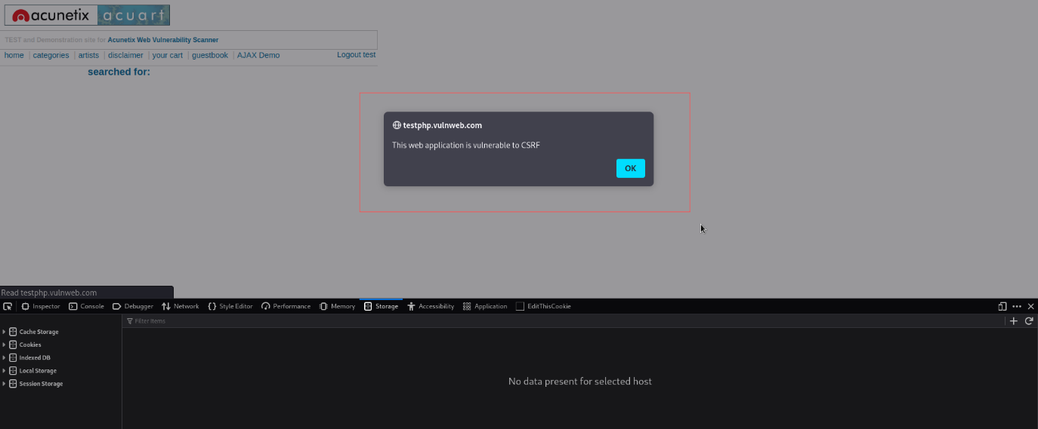
Image 1 – CSRF.png
- Testing for cookies attributes (CWE-315 - CWE-614)
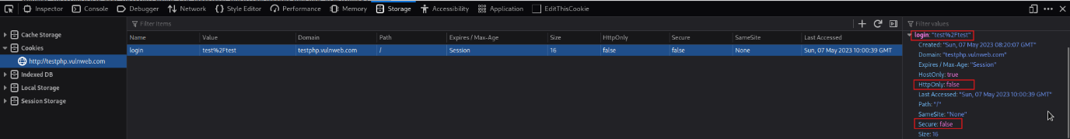
Image 1 – CWE-315 - CWE-614.png
Remediation | To remediate this vulnerability, the application must ensure that access controls are properly implemented and enforced. This includes:  - Implementing proper authentication mechanisms, such as strong password policies  and multi-factor authentication.  - Implementing proper authorization mechanisms, such as role-based access control  or attribute-based access control.  - Ensuring that all resources are properly protected and access is restricted to  only those who need it.
References | https://owasp.org/Top10/A2/

Security Misconfiguration
CVSS Severity | Medium |  | CVSSv3 Score |  | 6.5
CVSSv3 criterias | Attack Vector : | Network | Scope : | Unchanged
CVSSv3 criterias | Attack Complexity : | Low | Confidentiality : | Low
CVSSv3 criterias | Required Privileges : | None | Integrity : | Low
CVSSv3 criterias | User Interaction : | None | Availability : | None
Affected scope
Description | Security misconfiguration can occur in all layers of a web application stack, including the web server, application server, database, platform, and framework. It can result from an incomplete or ad hoc configuration, insecure default settings, or a lack of secure coding practices. Common examples of misconfigurations include: - Default or weak passwords for administrative interfaces - Misconfigured SSL/TLS settings, including weak ciphers or expired certificates - Incomplete or ad hoc configuration of firewalls and network devices - Insecure default configurations for web frameworks or libraries - Unnecessary or excessive permissions and privileges granted to users and applications
Observation | Attackers can exploit security misconfigurations to gain unauthorized access to sensitive data or take over the application. Common attack scenarios include: - Exploiting default or weak passwords to gain administrative access - Exploiting SSL/TLS misconfigurations to intercept and modify traffic - Exploiting misconfigured network devices to gain access to internal systems - Exploiting insecure default configurations for web frameworks or libraries to launch attacks such as SQL injection or remote code execution - Exploiting excessive permissions and privileges granted to users and applications to escalate privileges and gain unauthorized access to data or systems.
Test details
1- Information Gathering :
- Fingerprint web server (CWE-756, CWE-1352)
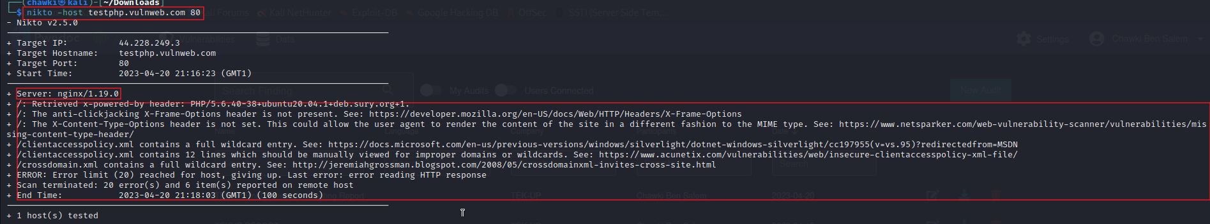
Image 1 – Nikto.png
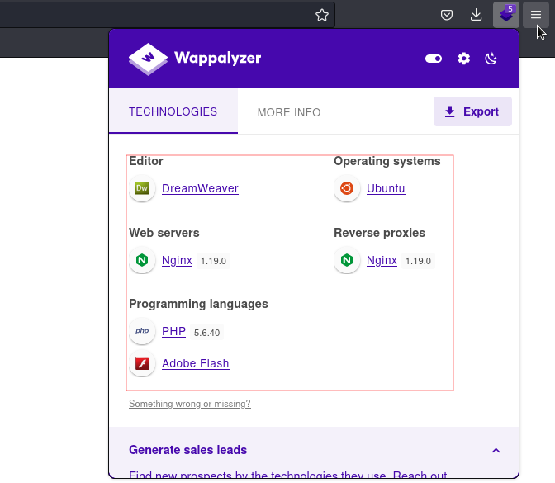
Image 1 – Wappalyzer.png
- Review Web server Metafiles for Information Leakage (CWE-200)
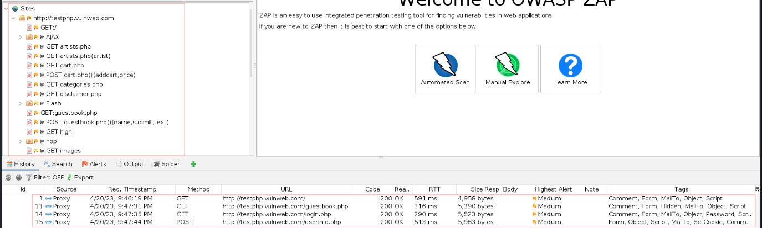
Image 1 – OWASP ZAP.png
6- Session Management
CWE-614: Sensitive Cookie in HTTPS Session Without 'Secure' Attribute.
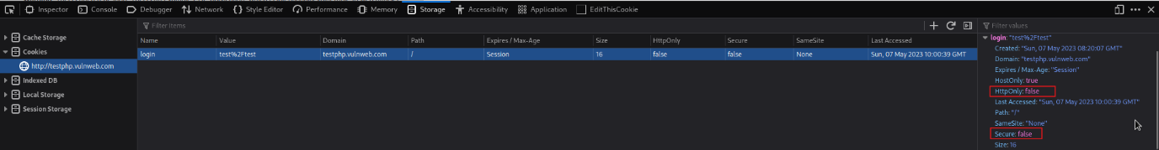
Image 1 – image.png
CWE-315 Cleartext Storage of Sensitive Information in a Cookie.
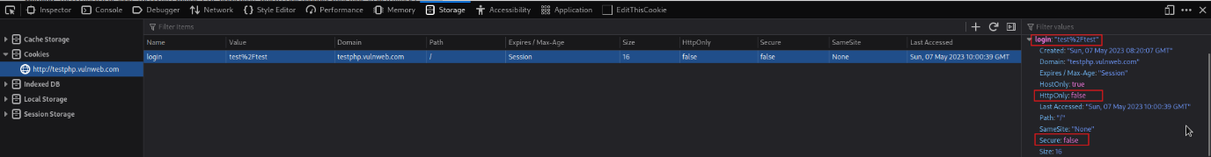
Image 1 – image.png
8- Error Handling :
- Improper Error Handling (CWE-728)
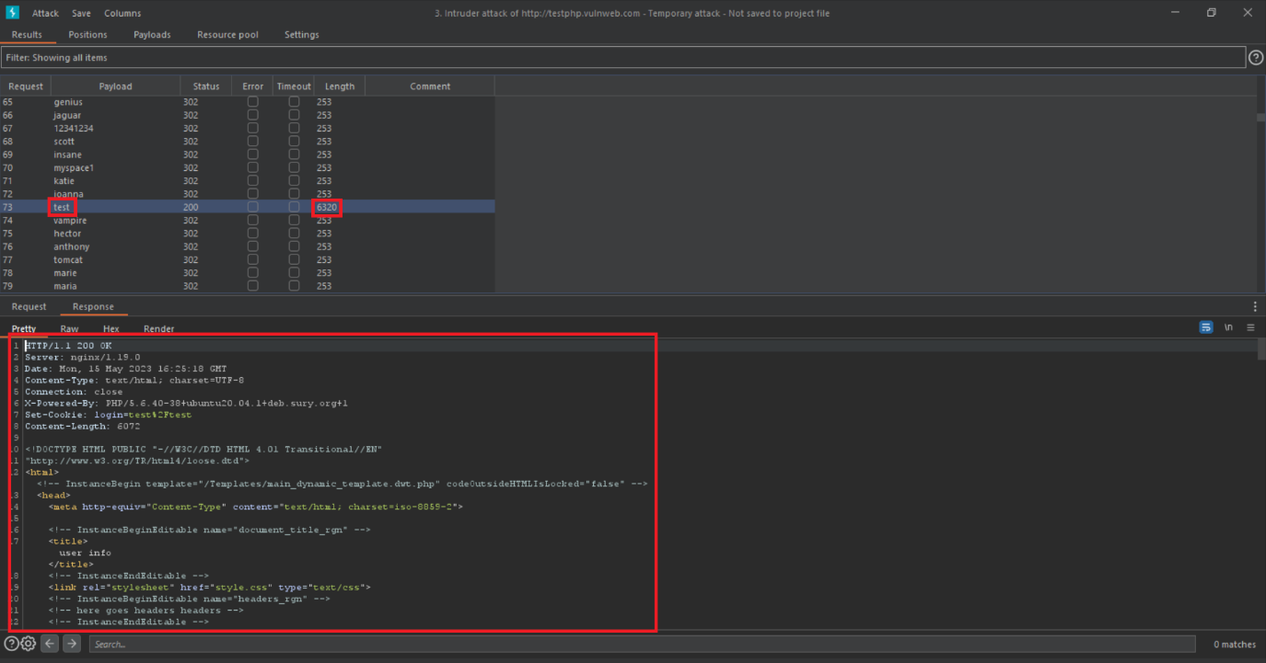
Image 1 – Insecure error handling for successful failed login.png
- Missing Standardized Error Handling Mechanism (CWE-544 )
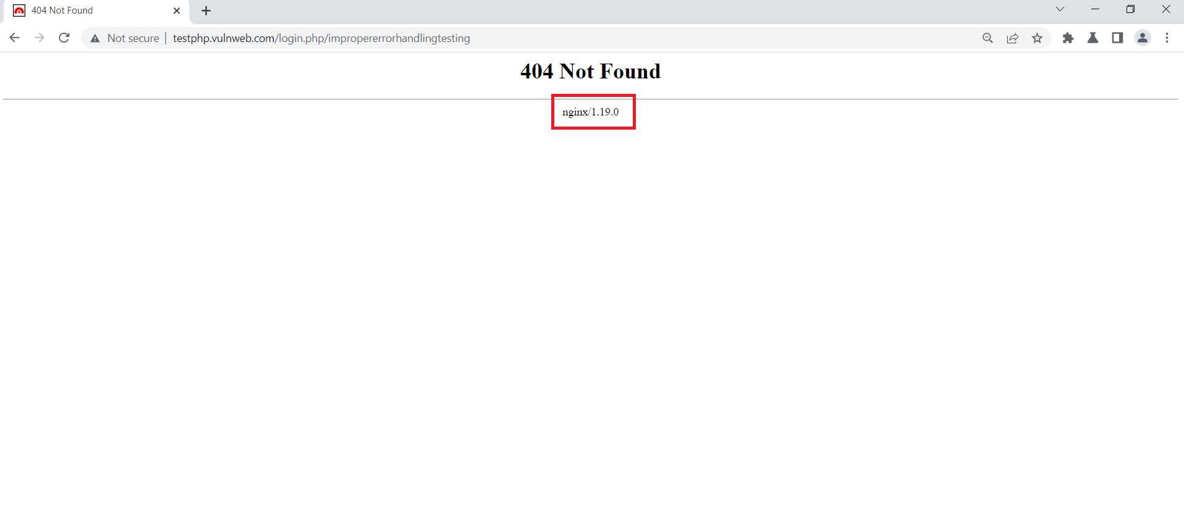
Image 1 – Improper error handling.png
Remediation | The following remediation steps can help mitigate security misconfigurations:  - Implement secure default configurations for all frameworks, libraries, and applications.  - Use strict access controls to prevent unauthorized access to sensitive data.  - Regularly update and patch all software components, including operating systems, web servers, databases, and third-party libraries and frameworks.  - Regularly conduct vulnerability scanning and penetration testing to identify and mitigate misconfigurations.
References | https://owasp.org/Top10/A05_2021-Security_Misconfiguration/

